Lilly Bryan
CS 360
Module 3-2
3/29/2026

Android Studio Introduction

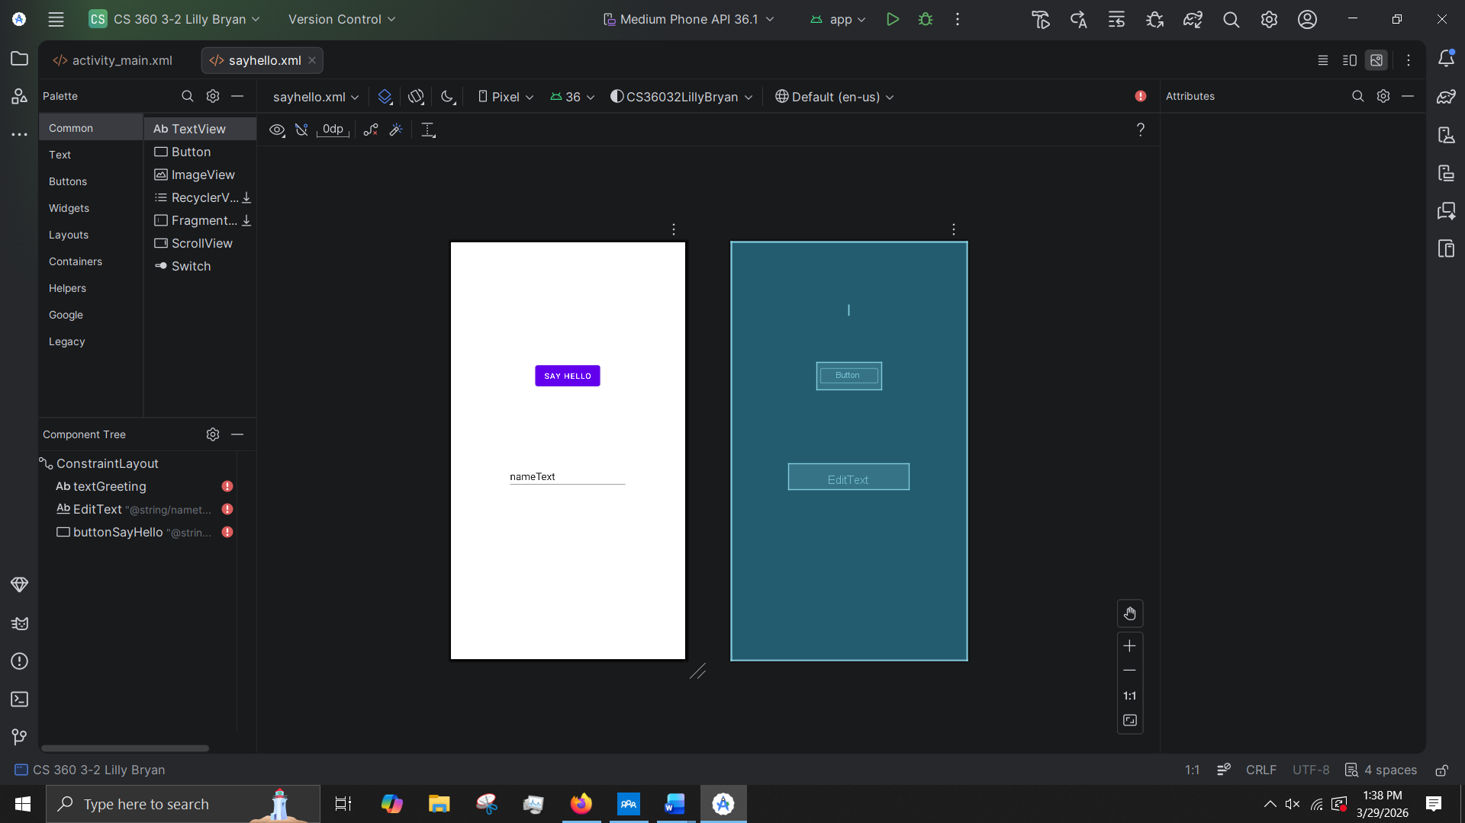
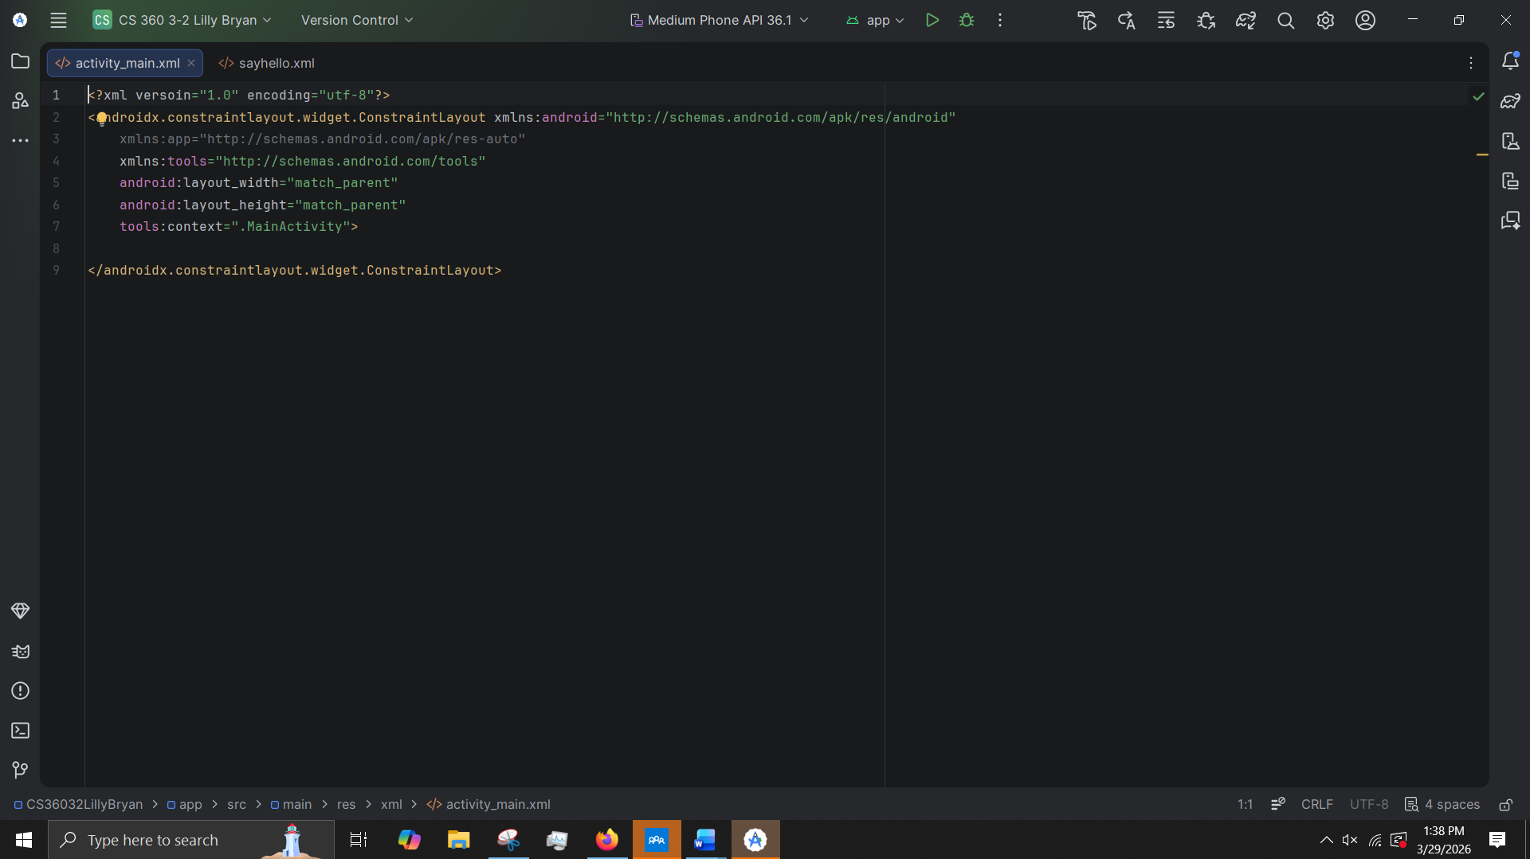
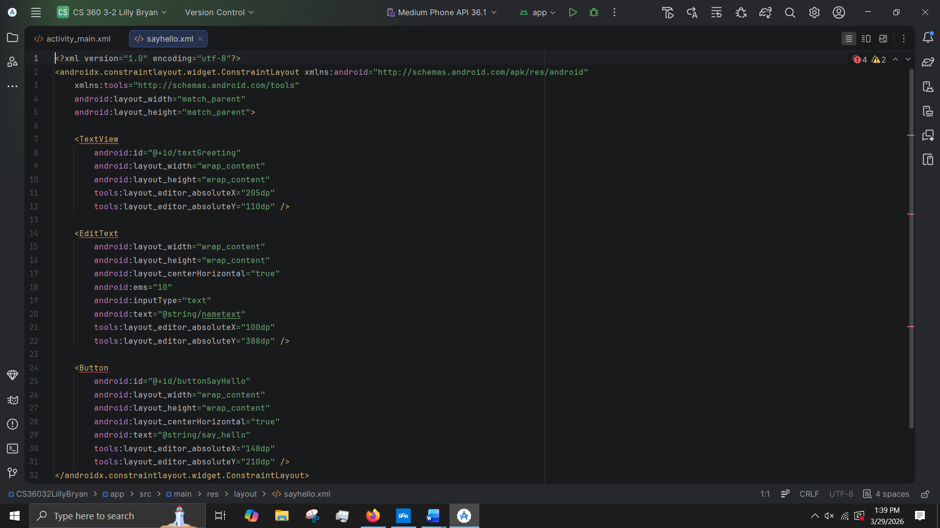

Like any new application or software, Android Studio took a little bit to get used to and figure out where different screens and menus are located. After doing some manual testing and research, I was able to figure out how the software works. The only thing I really had a challenge with was figuring out to get the objects to be placed center of the screen via the attributes instead of manually moving them. I still do not know how to do this and just did it manually instead. I do like the layout editor. It is nice to switch between the editor view and the code view to see exactly how the objects are made, transformed, and used with xml.

